John Wensink

ITS410 - Database Management

Colorado State University-Global Campus

Dr. Dan Morrill

November 17, 2019

World_X Database

This week we began to dive into the MySQL open-source RDBMS. When operating a business, it makes economic sense to use open-source software as it reduces or eliminates costly license fees. “The goal of any physical or legal is to be efficient, meaning longterm profitability.” (Strode, 2011) In this lesson, we created several different databases including jumpstart, world-x, and classicmodels. We learned about basic SQL commands to create users, tables, grant and revoke privileges, as well as add and drop rows to existing tables.

**Installing MySQL**

I followed the Windows installation of MySQL and it couldn’t have been easier. I navigated to the download page and installed the most recent release. The MySQL application came pre-loaded with the workbench and an external command prompt that I saved to my taskbar. Python 3.4 was suggested and installed at the same time for use later in the course. I am glad that we are using Python because that was the first programming language that I have taken a class in.

**Creating Users and Granting Privileges**

By using the root privileges, a new user was created called jump using the command:

CREATE USER 'jump'@'localhost' IDENTIFIED BY 'start';

With the new user created, privileges were granted in order to give the new user access to the world-x database functions, specifically, insert, update, select, delete, and index.

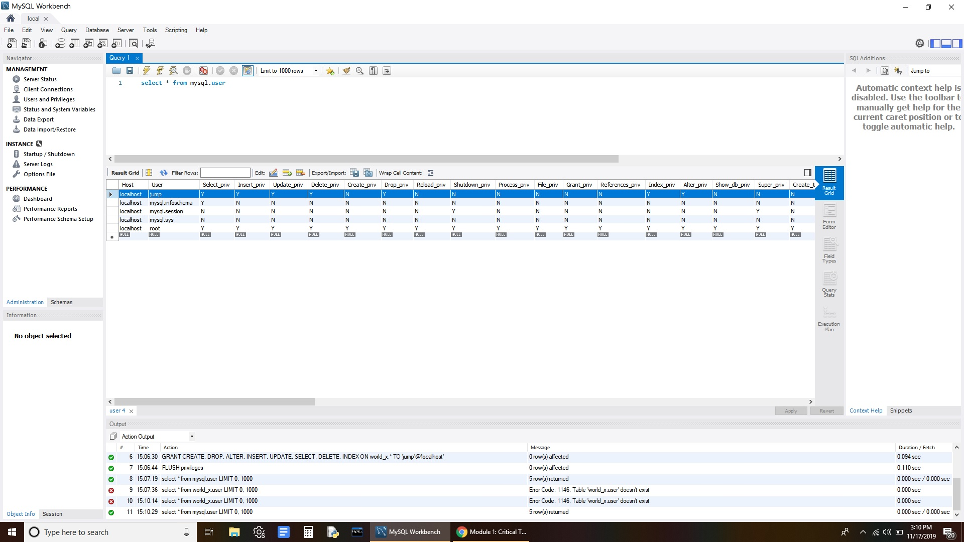

Grant is a command that is used to control database security. Databases should not be commonly operated with root privileges unless they are required. Rather, databases should be operated with users with the minimum required functionality to handle the tasks at hand. Databases are most vulnerable when attackers gain access to root privileges, granting broad access to the entirety of the database. We can make an attacker’s job more difficult by safeguarding access to root privileges by operating our databases with the least privileged accounts required to take care of the necessary operations. “Unauthorized access and SQL injection were found to be the two most common forms of hacking, an interesting finding given that both of these exploits are well known and often preventable.” (Murray, 2010 p. 62)

**Creating the Databases**

The text, as well as the interactive lecture, described two databases that we would be using during this class named jumpstart and classicmodels. Wanting to make sure I was well practiced in the materials presented in this course, I created the jumpstart, world, world-x, and classicmodels databases. Jumpstart was the easiest to create. I installed jumpstart manually by using the command:

CREATE DATABASE jumpstart;

The creation was verified using the command:

SHOW DATABASES;

In the jumpstart database, I practiced adding rows, filling the rows with data, and dropping rows. The textbook provided examples and it was simple to follow along.

Next, I installed the databases world, world-x, and classicmodels. These databases were a bit different as they were created using pre-created SQL scripts downloaded as zip files. Creating these databases was also straightforward by using the menu function “Open SQL Script” (Ctrl + Shift + O) and executing the code. Again, the database creation was verified by using the SHOW DATABASES; command. These databases had rows and columns already populated and ready to use.

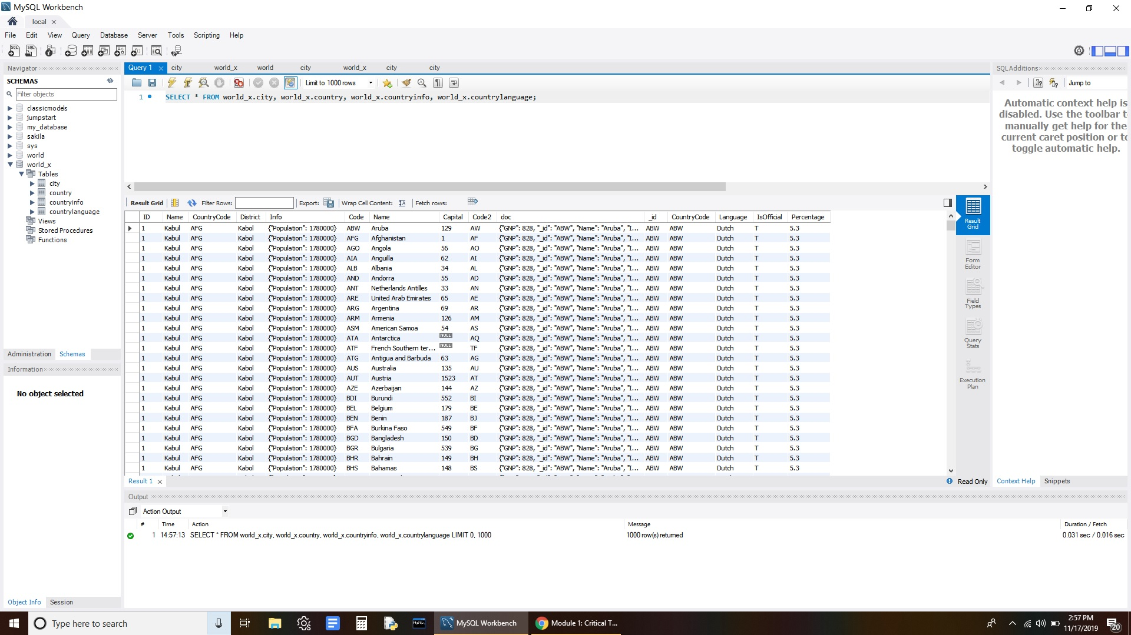

References

Boronczyk, T. (2015). *Jumpstart MySQL*. Collingwood, AUS: SitePoint Pty. Ltd.

Murray, M. C. (2010). Database Security: What Students Need to Know. *Journal of Information Technology Education: Innovations in Practice*, *9*, 061–077. Retrieved from <http://www.jite.org/documents/Vol9/JITEv9IIPp061-077Murray804.pdf>

Stroe, I. (2011). MySQL databases as part of the Online Business, using a platform based on Linux. *Database Systems Journal*, *11*(3), 3–12. Retrieved from <http://www.dbjournal.ro/archive/5/1_Stroe.pdf>